

**Continuing**

**Education**

**Program**

**Center for Computing and Information Technology**

**Faculty of EngineeringUniversity of Indonesia**

**PROJECT ON**

**“My Kost”**

**Group : 1**

**Muhammad Hudya Ramadhana**

**Mutia Ayu Dianita**

**­­**

**Faculty : Dudy Fathan Ali S.Kom**

**Class : 4 SC 1**

Faculty of Engineering University of Indonesia

Depok 16424

2017

**PROJECT ON**

*My Kost*

Developed By

*Name : Muhammad Hudya Ramadhana*

*Mutia Ayu Dianita*

NIIT

**RENTHOUSE**

Batch Code : 4 SC 1

Start Date : May 9th, 2017

End Date : June 4th, 2017

Name Of The Coordinator : Dudy Fathan Ali S.Kom

Name Of Developer : Muhammad Hudya Ramadhana

Mutia Ayu Dianita

Date Of Submission : June 5th, 2017

NIIT

**CERTIFICATE**

This is to certify that this report, titled Rent House embodies the original work done by ***Muhammad Hudya Ramadhana and Mutia Ayu Dianita*** in partial fulfillment of their course requirement at NIIT.

Coordinator:

*Dudy Fathan Ali S.Kom*

**ACKNOWLEDGEMENT**

We have benefited a lot from the feedback and suggestions given to us by Mr. Dudy Fathan Ali S.Kom and other faculty members. The Project presentation opportunity we have with CCIT-FTUI is a greatchance for learning and professional development. Therefore, we consider ourselves very lucky as we are provided with an opportunity to be a part of it. We are also grateful for having a change to meet so many wonderful people and professionals who led us through this project period.

Bearing in mind, we would like to express our deepest gratitude and special thanks to Mr. Dudy Fathan Ali S.Kom of CCIT-FTUI faculty who is spite of being extraordinarily busy with her duties, took time out to hear, guide and keep us on the correct path and allowing us to carry out our project until completion.

Our Project assignment won’t be as good as it is now without any help, feedback and suggestion that were given to us by our friends within the campus. So, we would also like to say thank you to all of them. We will strive to use gained skills and knowledge in the best possible way, and we will continue to work on the improvements, in order to attain desired career objective.

**SYSTEM ANALYSIS**

**System Summary:**

The proposed software system for Rent House will be used by two different types of platform:

1. Desktop for Admin
2. Web for Customer and Admin

The proposed software system needs to provide the following functionalities to the Admin of My Kost:

1. Allow Admin to Add and Modify Room Types Data.
2. Allow Admin to Add and Modify Room Data.
3. Allow Admin to Add and Modify Admin Data.
4. Allow Admin to Add and Modify Customer
5. Allow Admin to Add Transaction (Rent In or Rent Out)
6. Allow Admin to Add Monthly Paid of Customer
7. Allow Admin to Add News at Website

The proposed software system also provide the following functionality to the Customer of Rent House :

1. Allow Customer to View Available Rooms in Rent House
2. Allow Customer to Make Account of Customer
3. Allow Customer to View Their Own Monthly Paid

**HARDWARE AND SOFTWARE REQUIREMENTS**

**Hardware: - Asus Expert 50, Intel(R) Core(TM) i38.00 GB (RAM)**

* **Hewlett Packard 14-n267tx, Intel(R) Core(TM) i5-4200U 4.00 GB (RAM)**

**Operating System: Microsoft Windows 8.1 Pro, 64-bit Operating System**

**Software: Astah Jude Professional**

**SQL Server 2015**

**Visual Studio 2010**

**INDIVIDUAL PROJECT SCHEDULE**

|  |  |  |  |  |  |
| --- | --- | --- | --- | --- | --- |
| **S. No** | **Activity Description** | **Planned Date of Completion** | **Actual Date** | **Responsibility** | **Remarks** |
| 1 | Creating the Database for Desktop | 16th May 2017 | 16th May 2017 | Mutia |  |
| 2 | Creating Database for Web | 16th May 2017 | 16th May 2017 | Hudya |  |
| 3 | Creating WCF Service | 21st May 2016 | 21st May 2017 | Hudya |  |
| 4 | Creating Desktop Application | 4th June 2017 | 2nd June 2017 | Mutia |  |
| 5 | Creating Web Application | 4th June 2017 | 2nd June 2017 | Hudya |  |

**WCF SYSTEM ARCHITECTURE DIAGRAM**

View News

View Available Room

Manage Customer

Manage Room Type

Manage Room

Manage Admin

Manage Transaction

Manage Monthly Paid

Manage Reservation

Login Admin

Add Customer

**WCF**

View Monthly Paid By ID

Create Customer Account

Login Admin

DATABASE

FOR WEB

DATABASE

FOR DESKTOP

**ACTIVITY DIAGRAM FOR MY KOST**

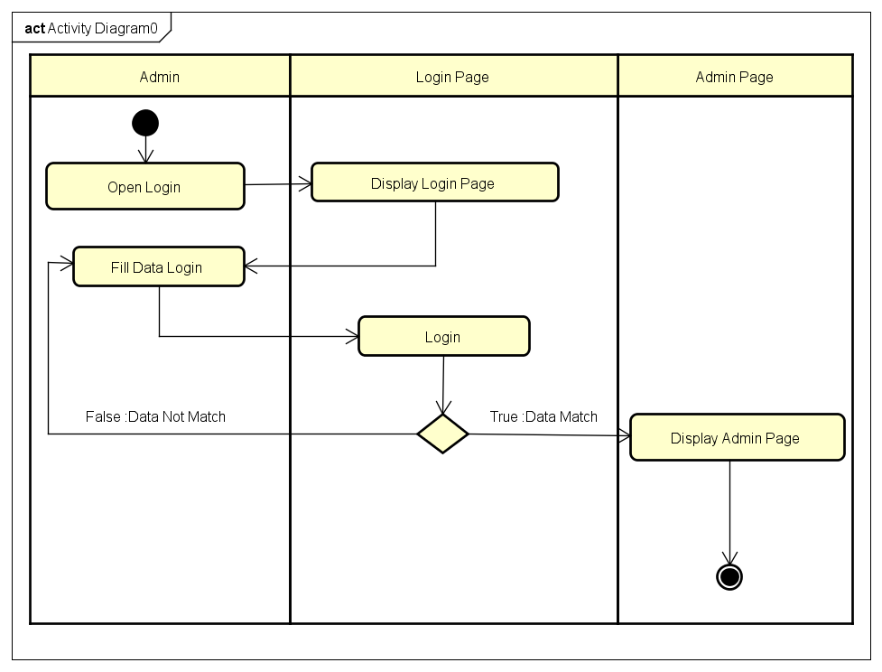

*Activity Diagram Login*

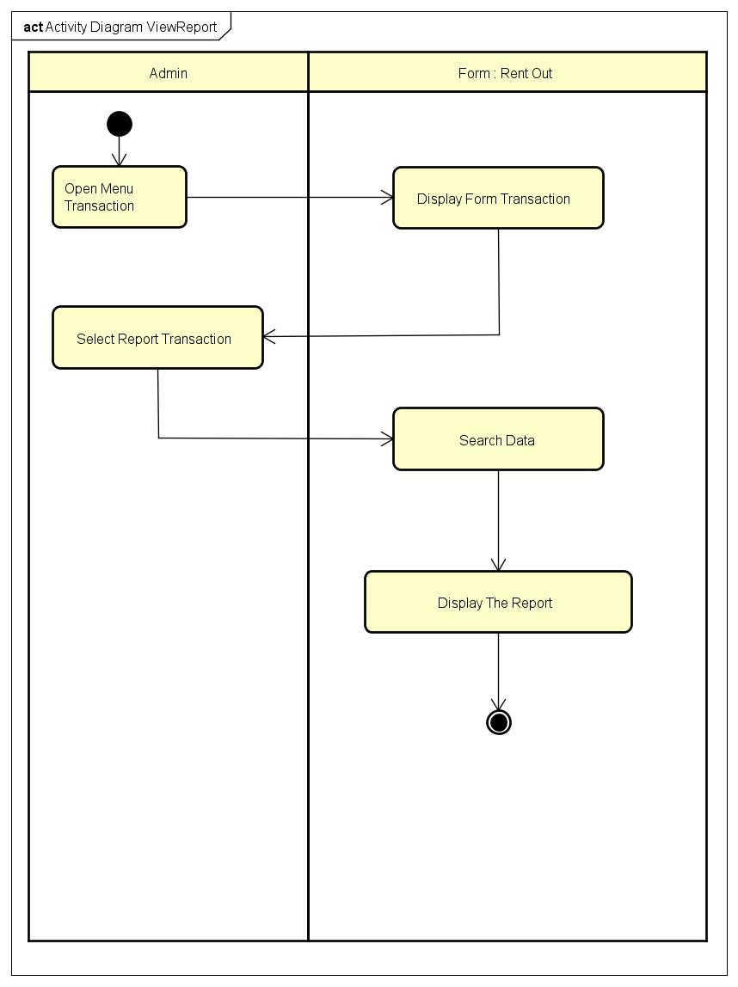

*Activity Diagram Display Report*

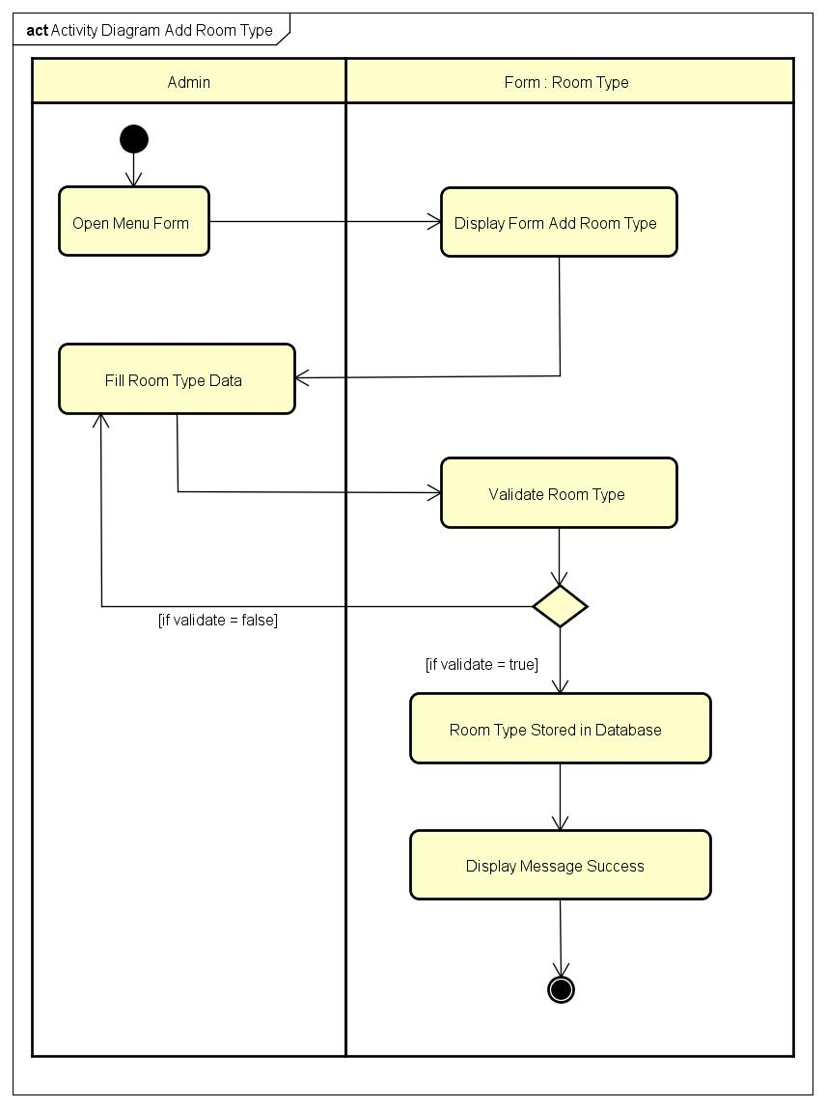

*Activity Diagram Add Room Type*

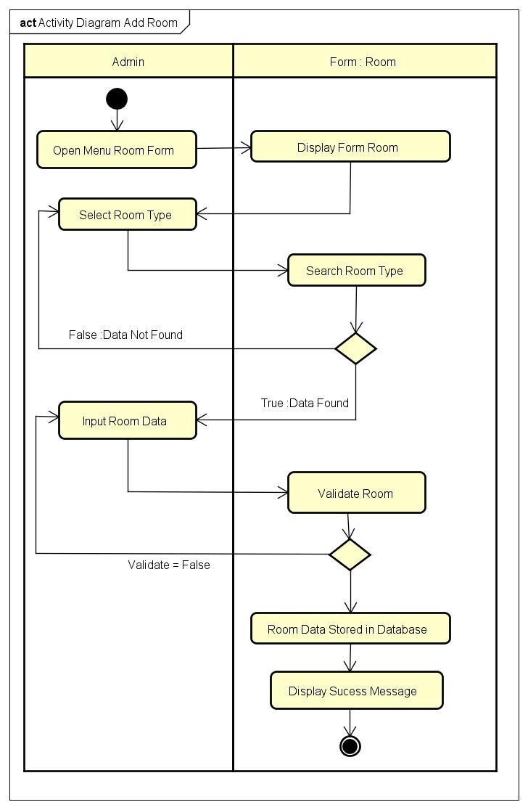

*Activity Diagram Add Room*

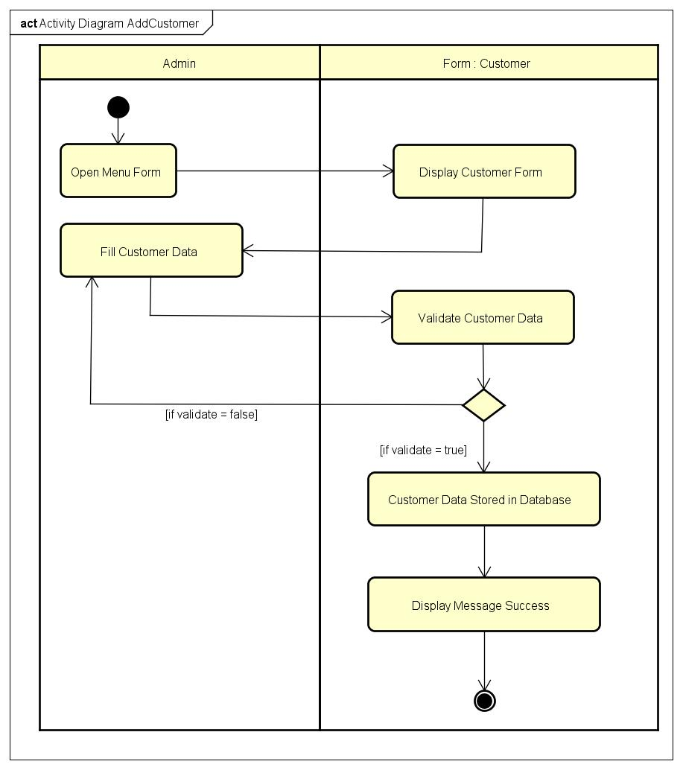

*Activity Diagram Add Customer*

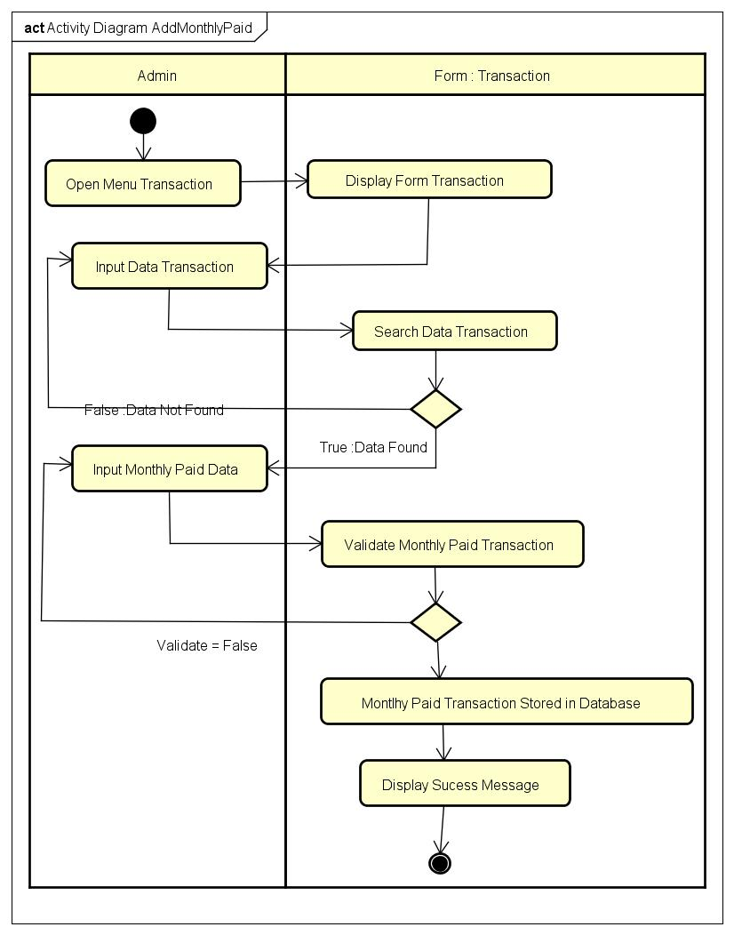

*Activity Diagram Add Monthly Paid*

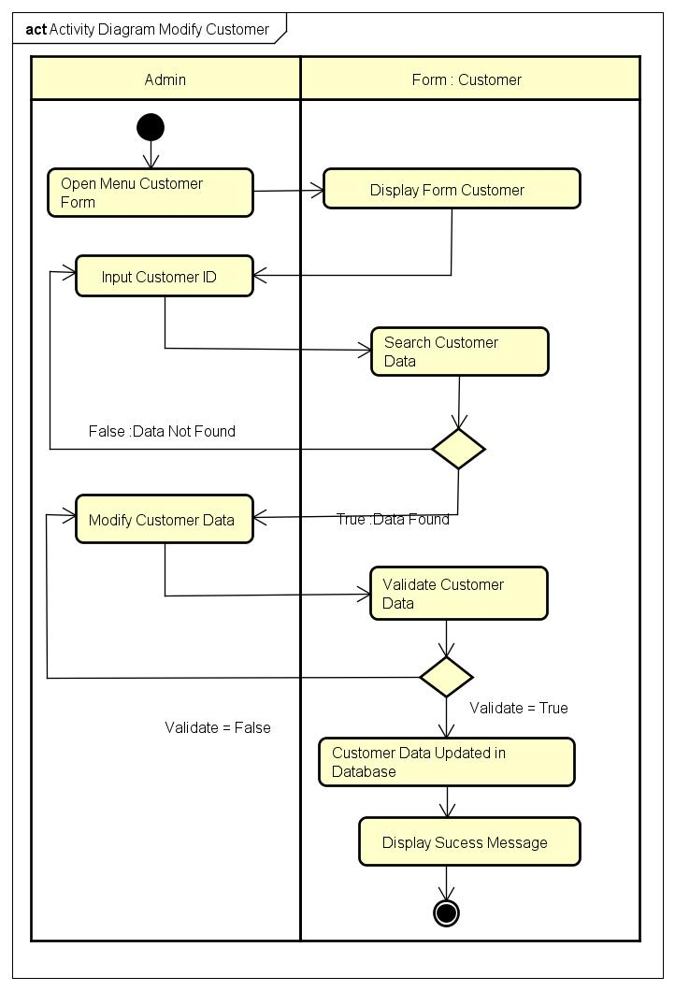

*Activity Diagram Modify Customer*

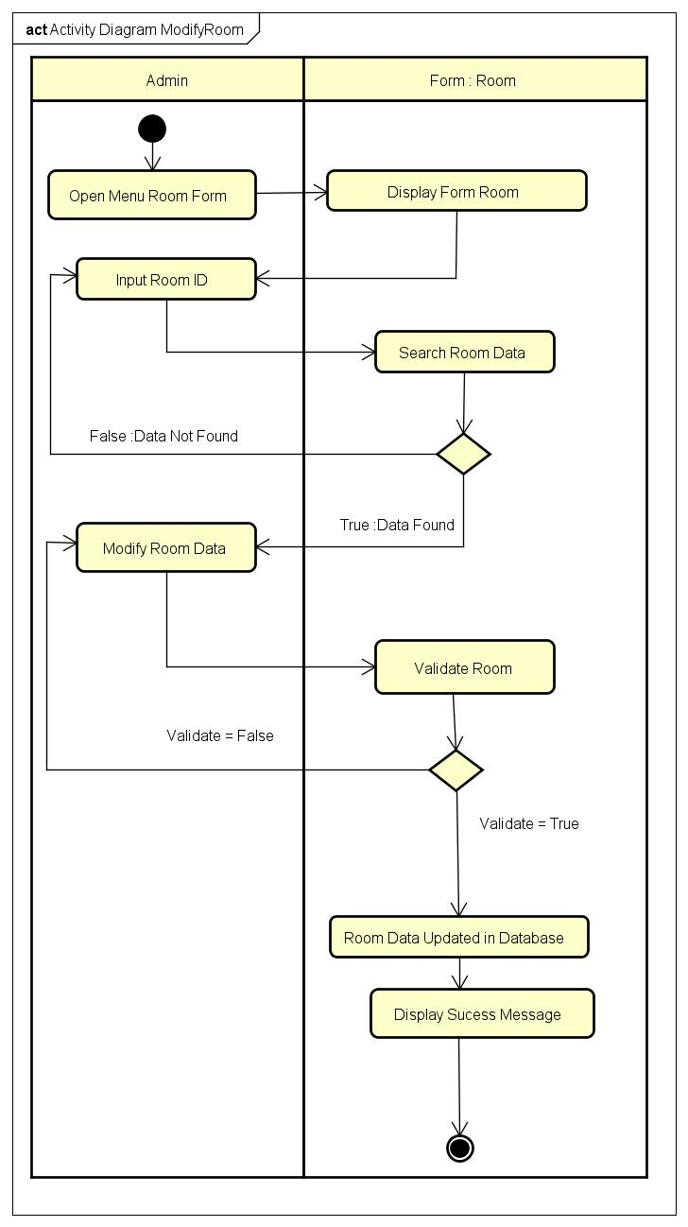

*Activity Diagram Modify Room*

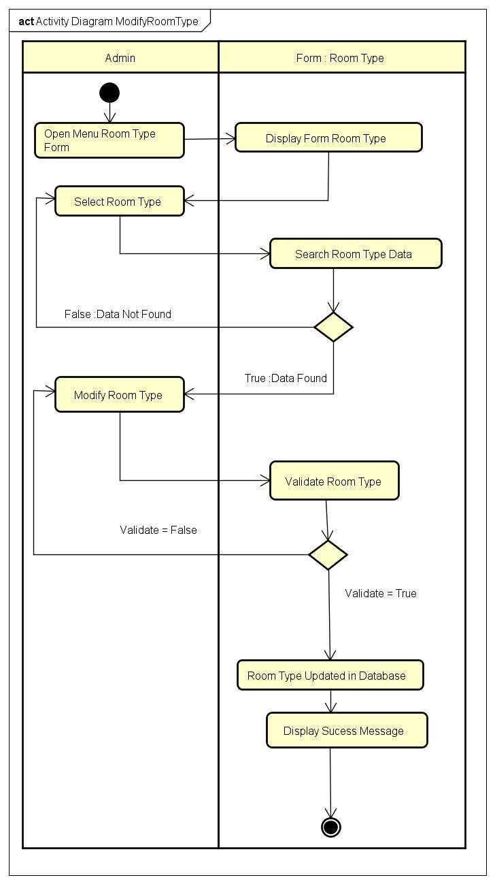

*Activity Diagram Modify Room Type*

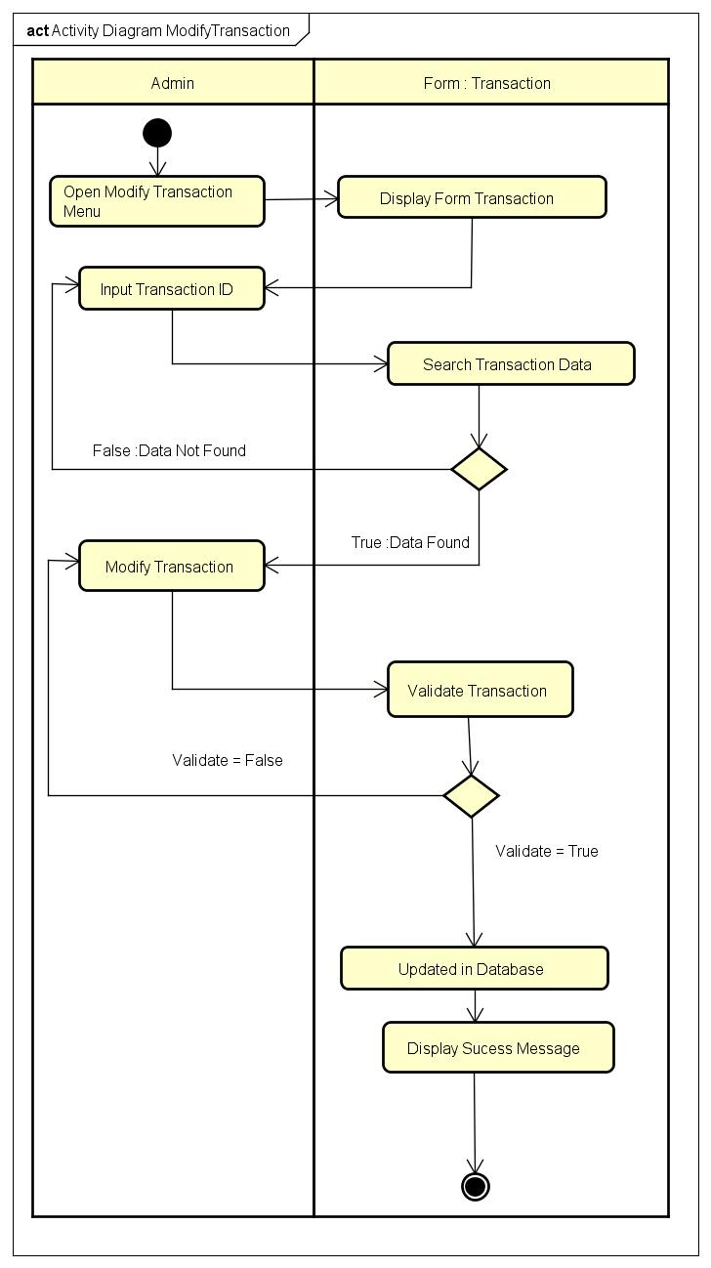

*Activity Diagram Modify Transaction*

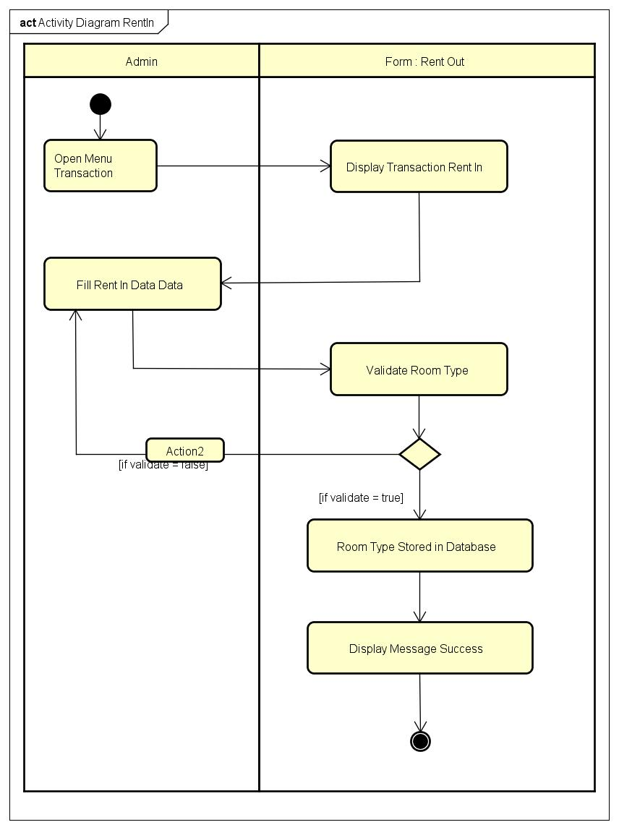

*Activity Diagram Rent In*

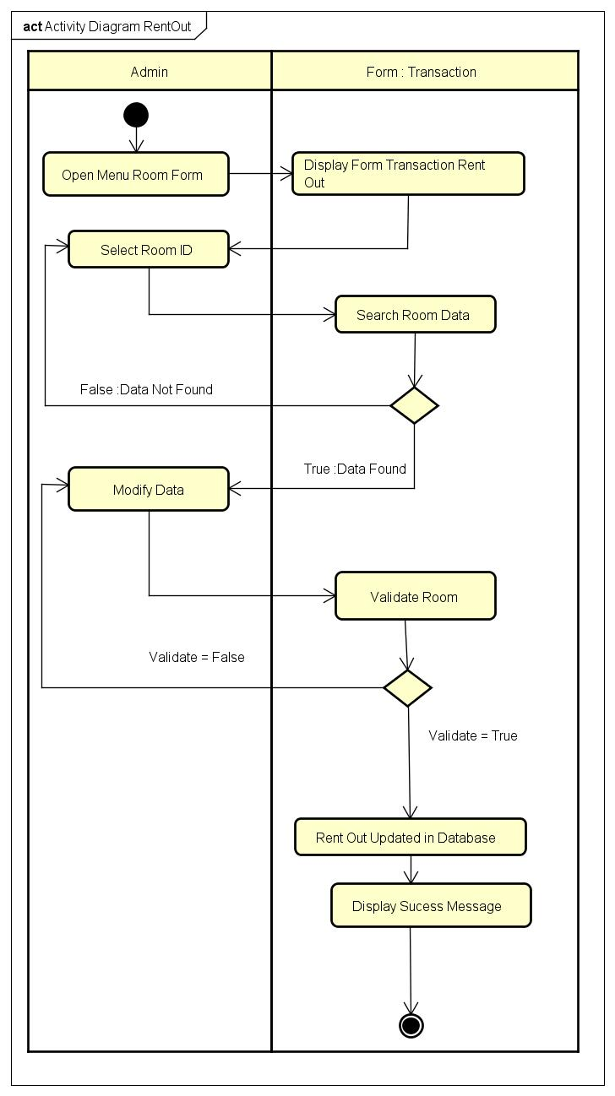

*Activity Diagram Rent Out*

**USE CASE DIAGRAM FOR RENT HOUSE**

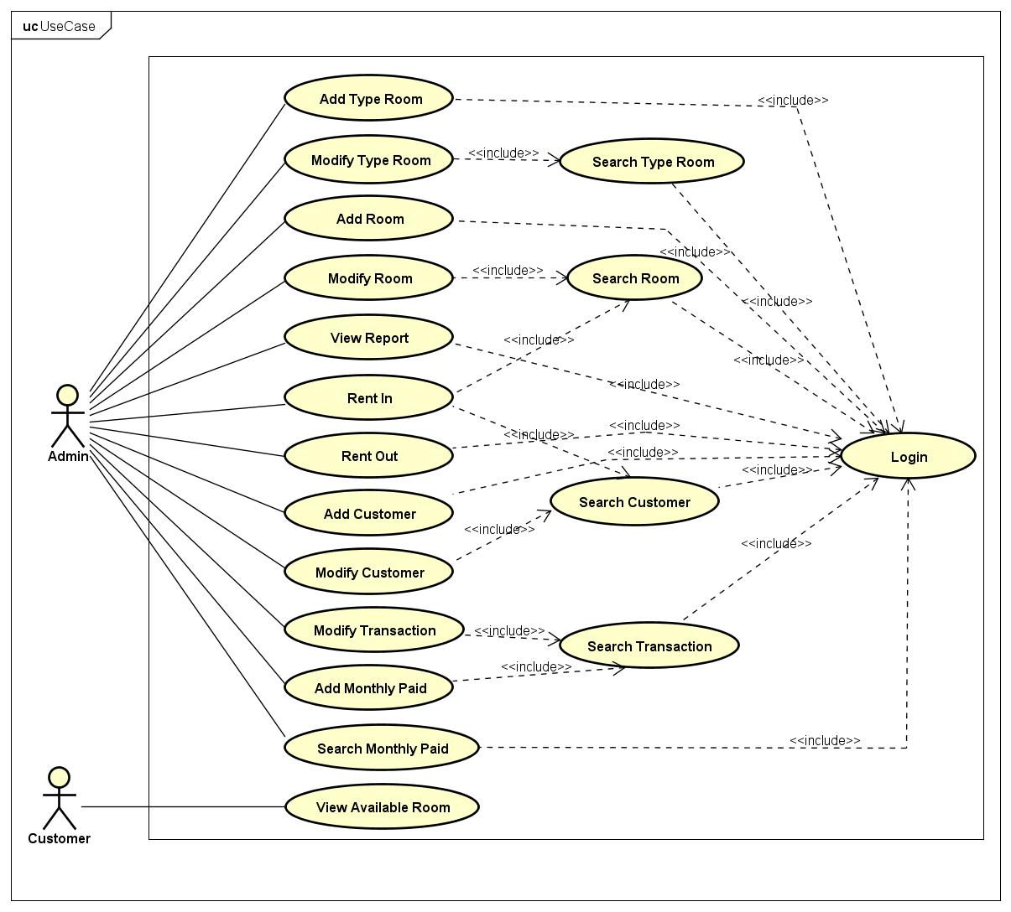

*Use Case Diagram*

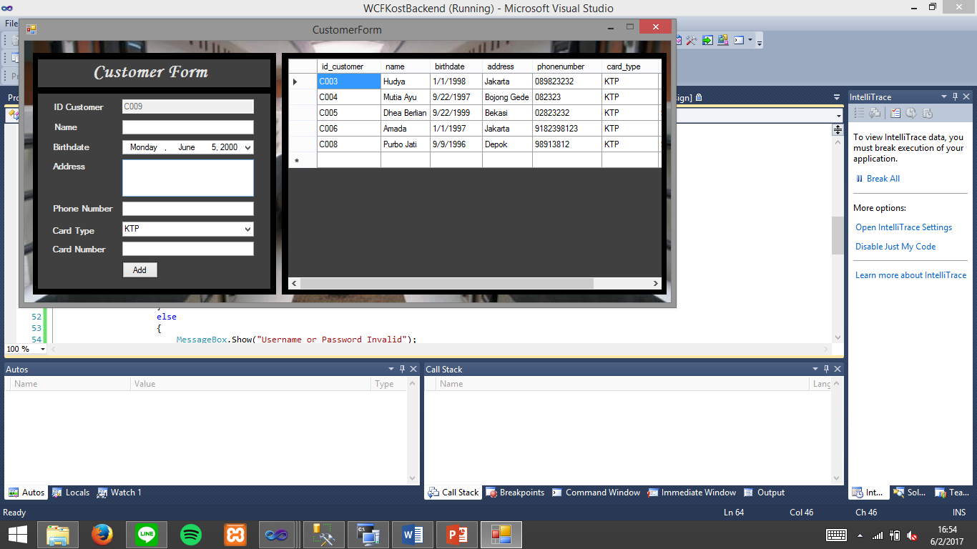

Customer Form

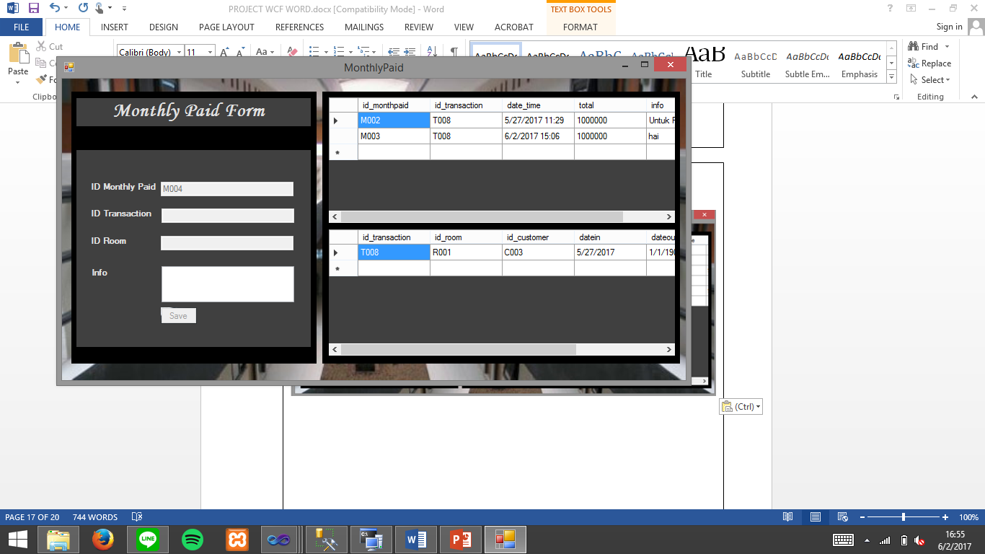

Monthly Paid Form

**INTERFACE OF MY KOST DESKTOP**

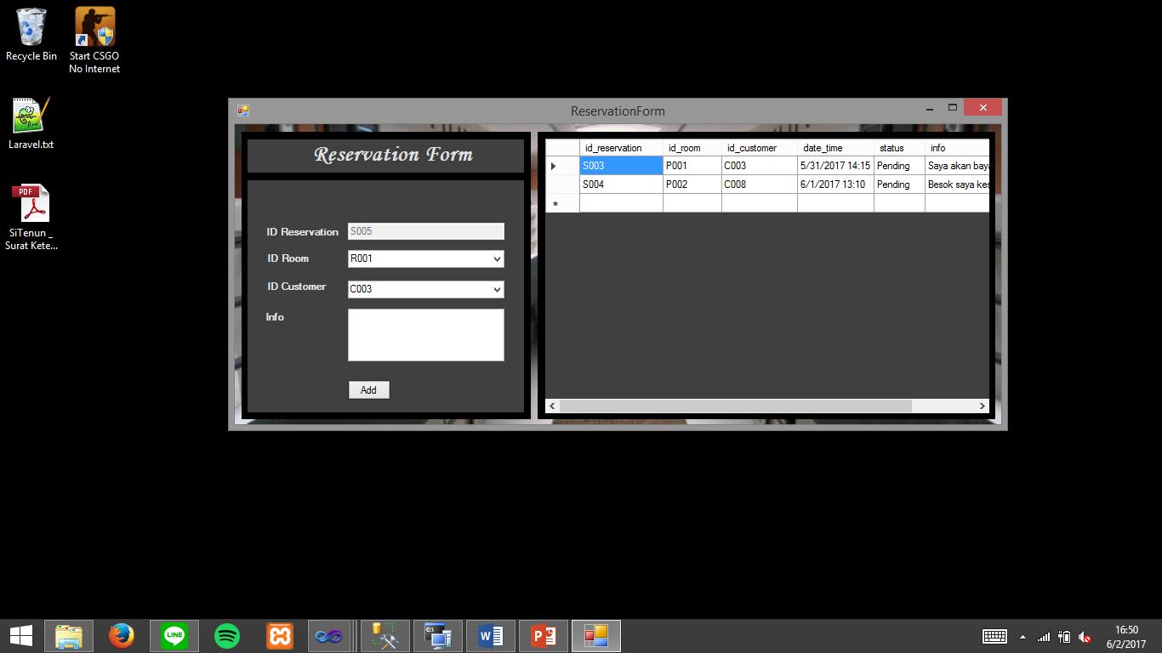

*Reservation Form*

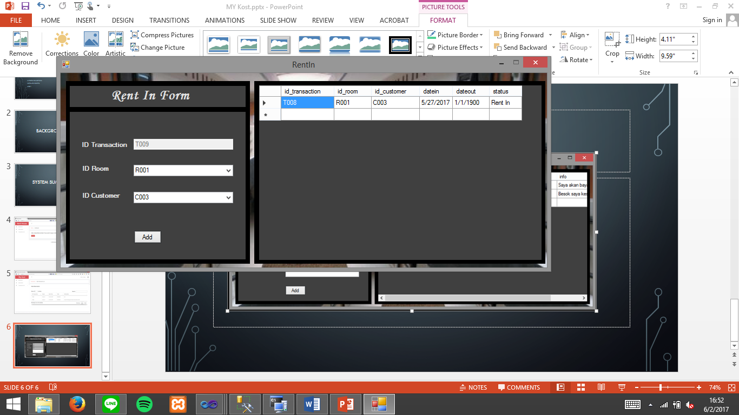

*Rent In Form*

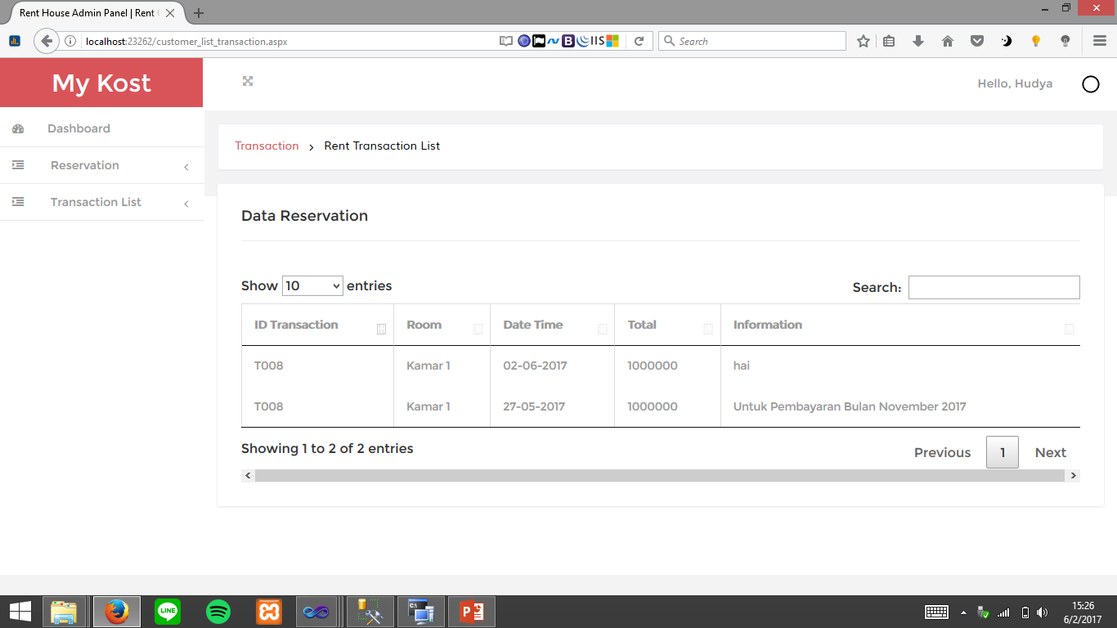

Transaction List

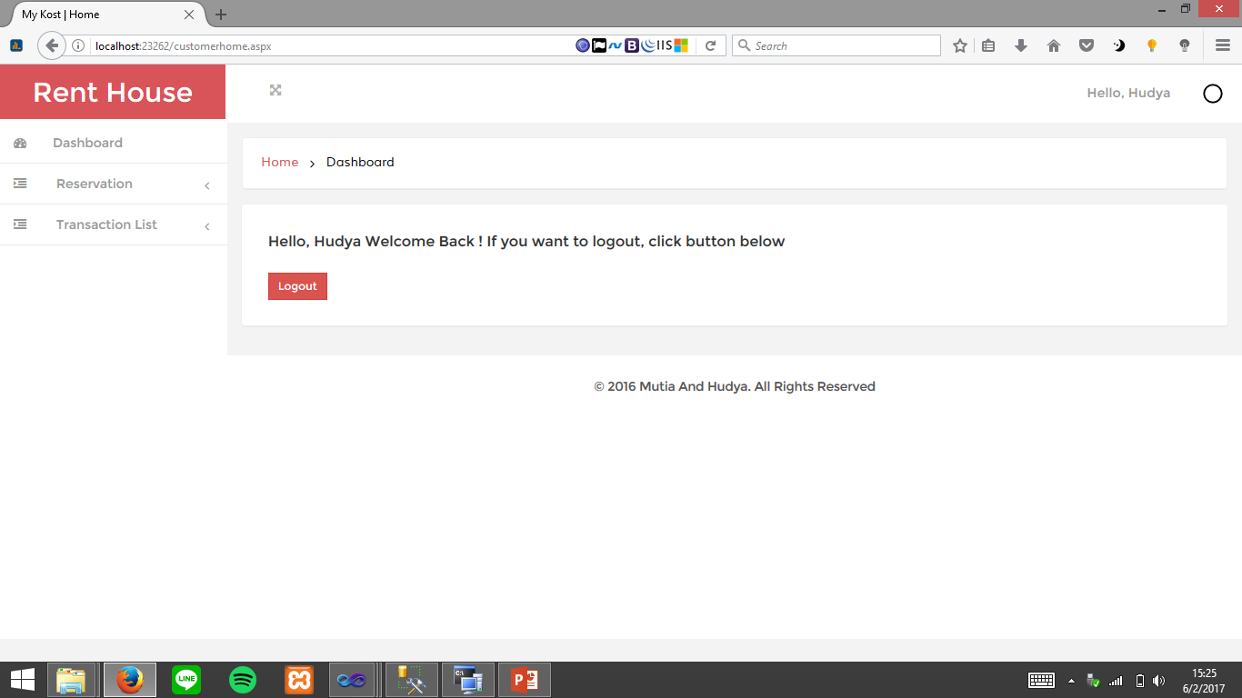

Dashboard Home

**INTERFACE OF MY KOST WEB**

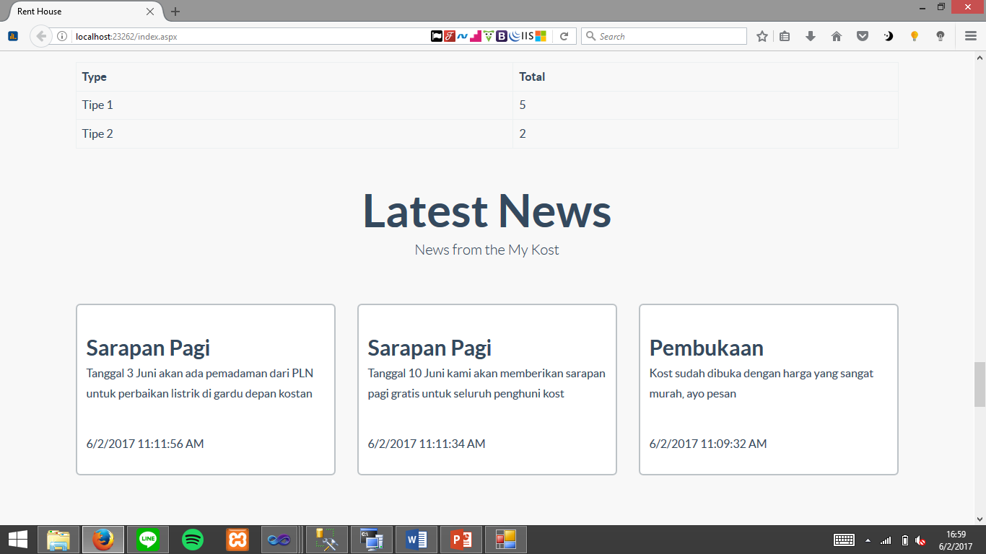

*Latest News*

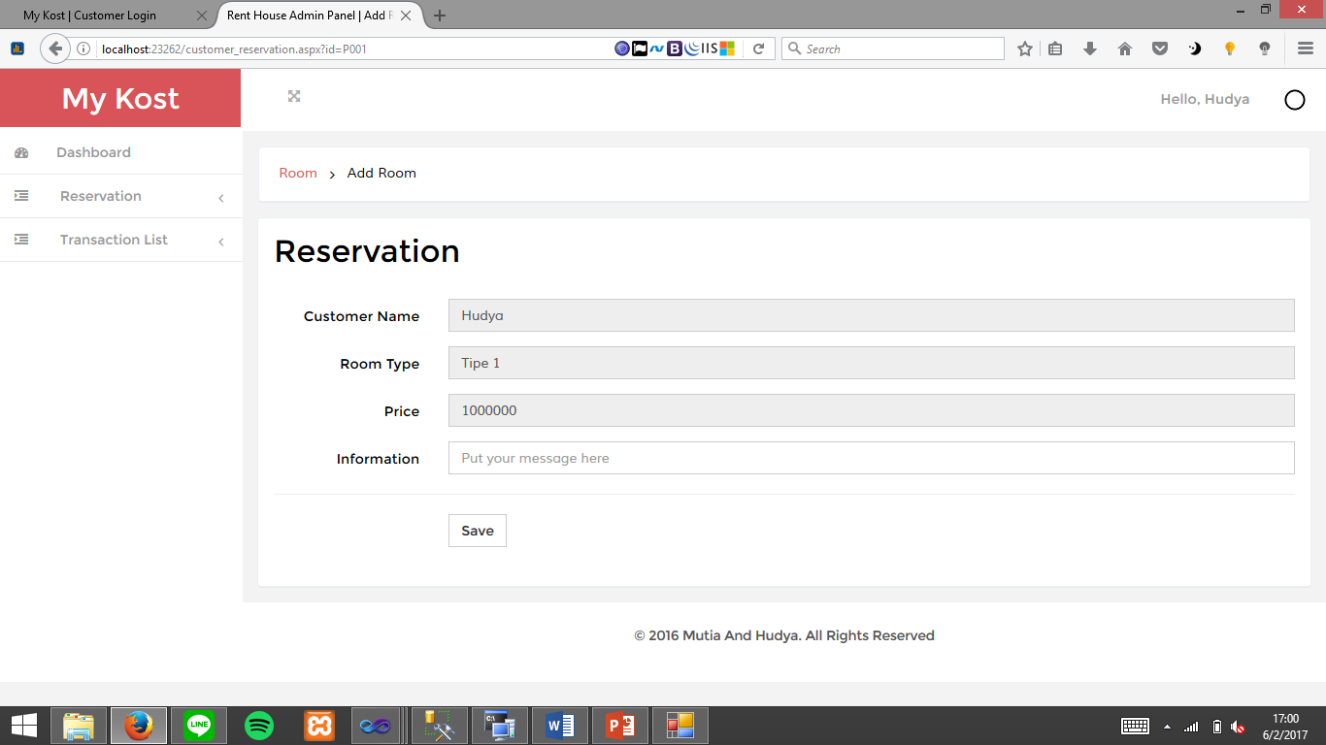

*Reservation Room*